Yifu He 10442277

Q1:

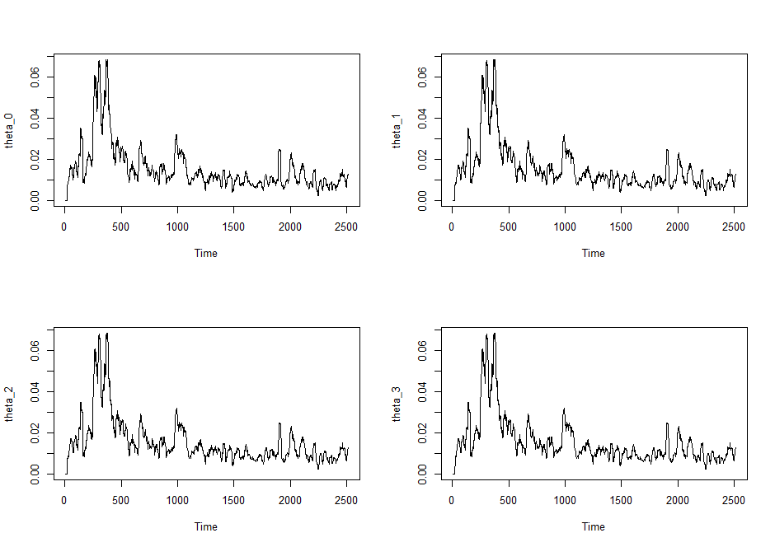

Comment:

The distribution of these 4 are similar, which give us the conclusion that the 3 estimate method are not much different from each other.

Q2:

1. Model Grach(1,1)

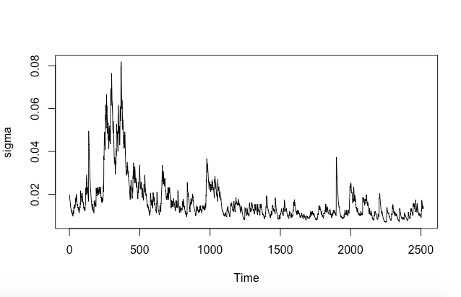

b)EMWA 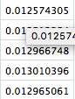

GRACH 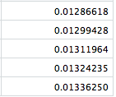

Q3:1) 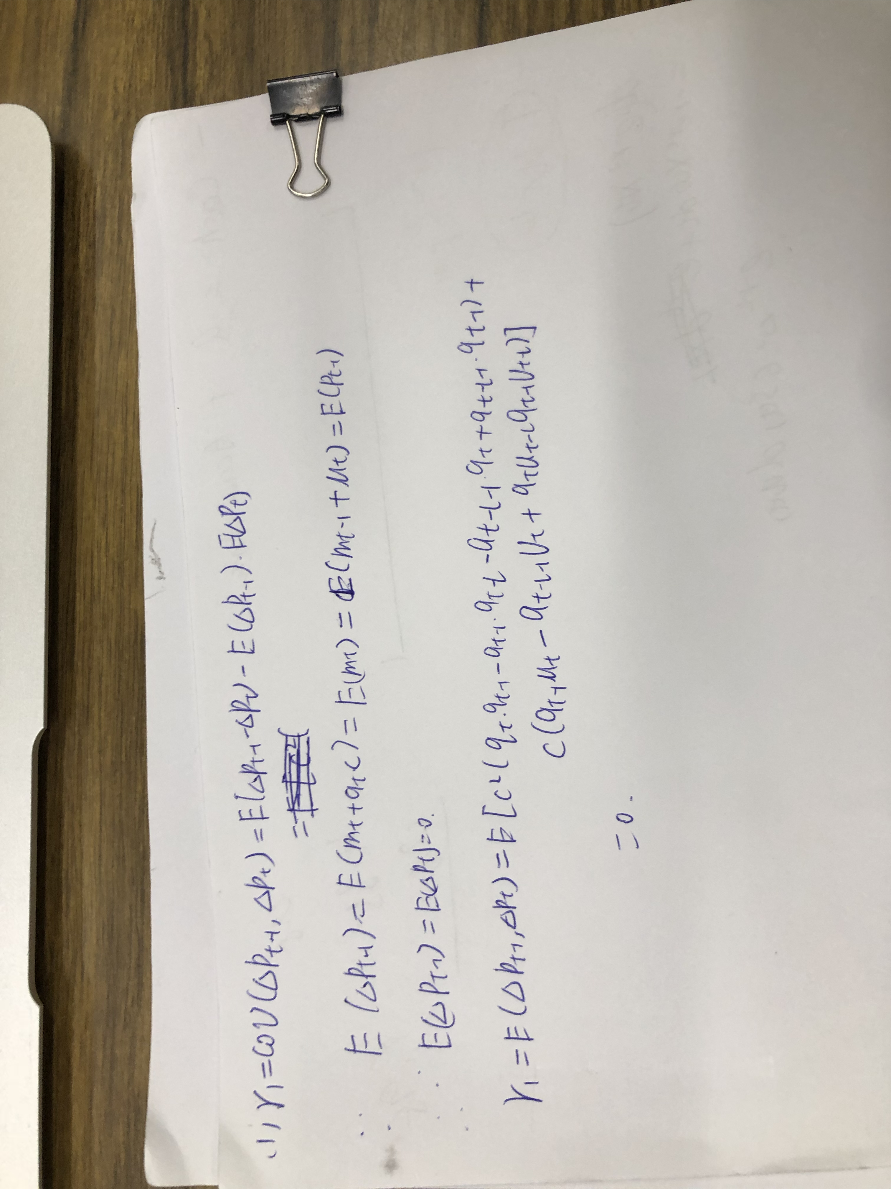

2)

Gama0



Gama1



C



Thetau



###Source code

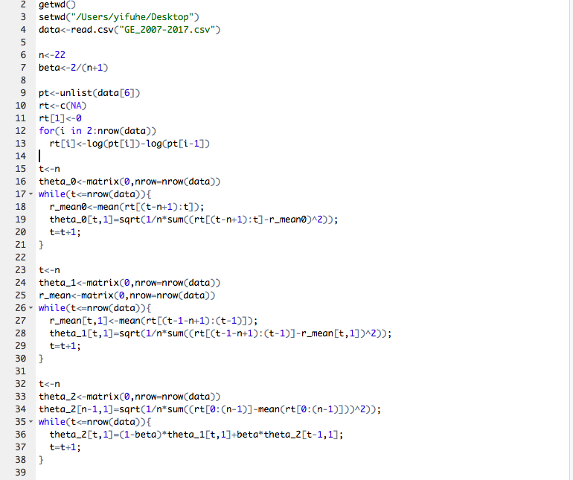

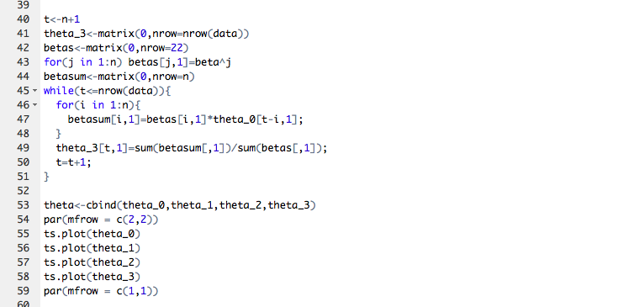

Q2: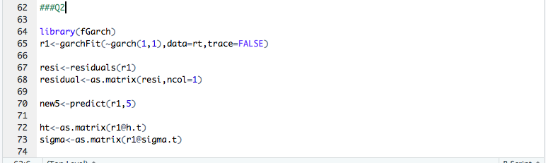

Q3: 